**PRACTICAL No.1(A) [LISTS]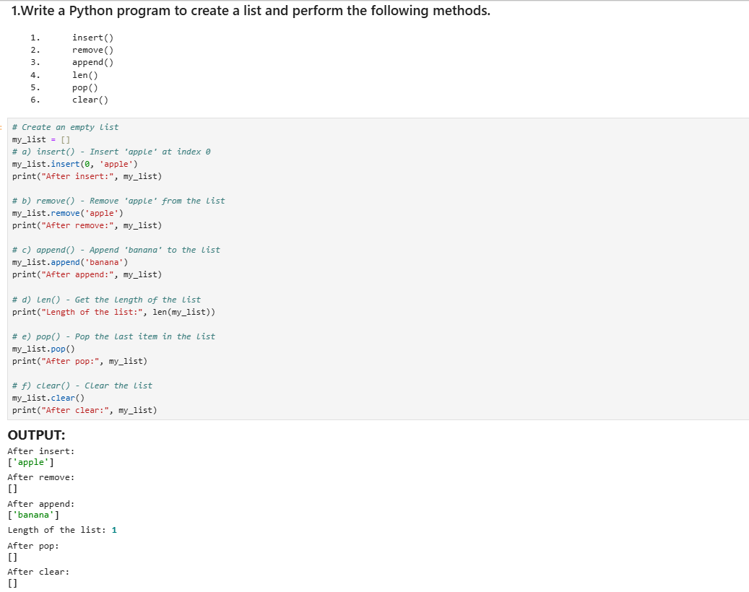

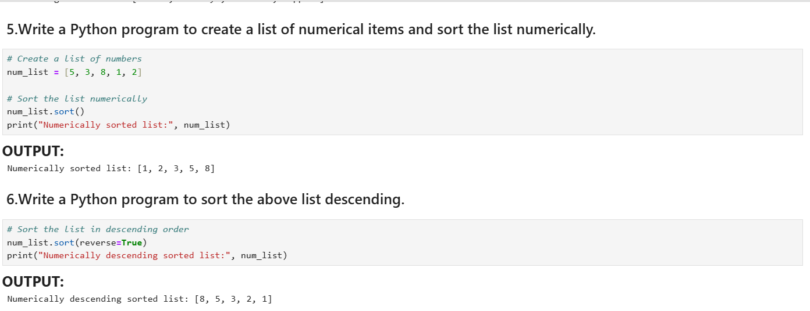

**PRACTICAL No.1(B) [TUPLES]**

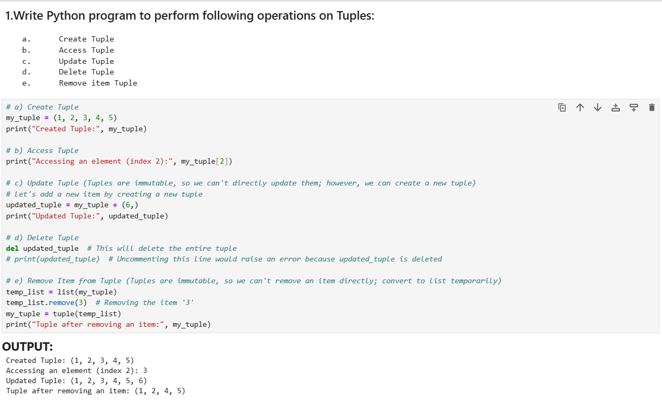

**PRACTICAL No.1(C) [DICTIONARIES]**

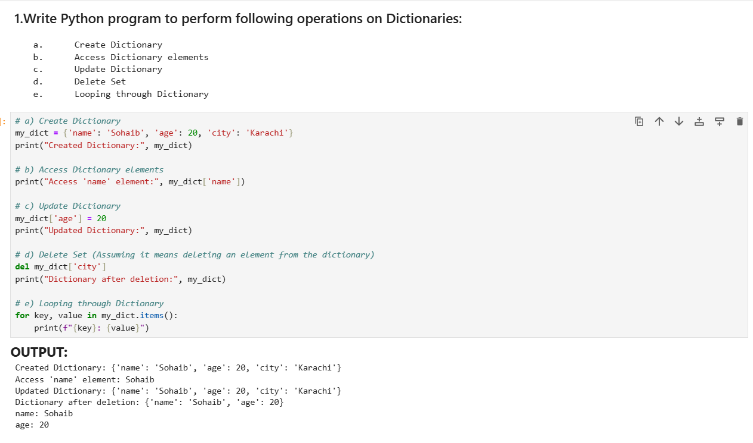

**PRACTICAL No.2(A) [User Defined Functions]**

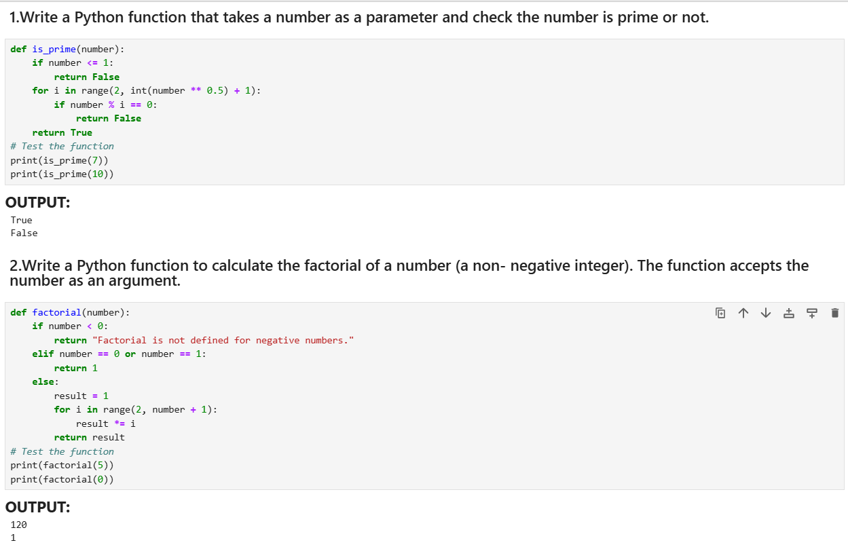

**PRACTICAL No.2(B) [MODULES]**

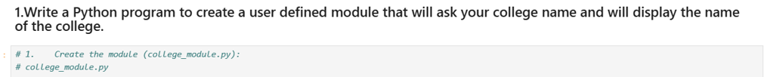

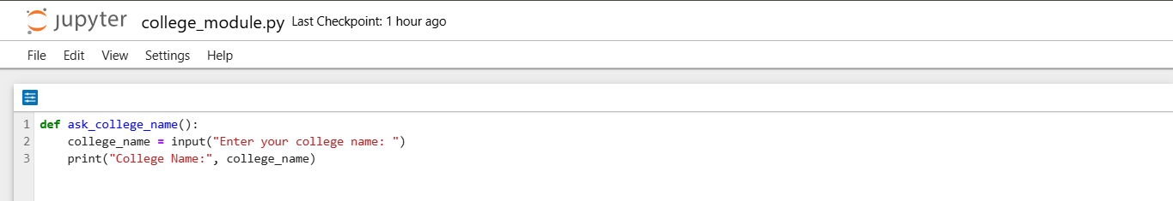

**PRACTICAL No.3 [NUMPY & PANDAS]**

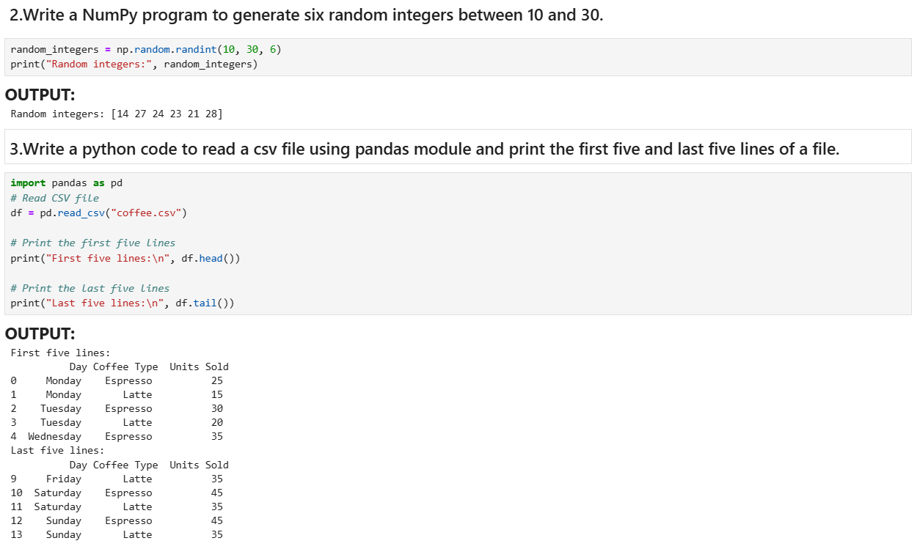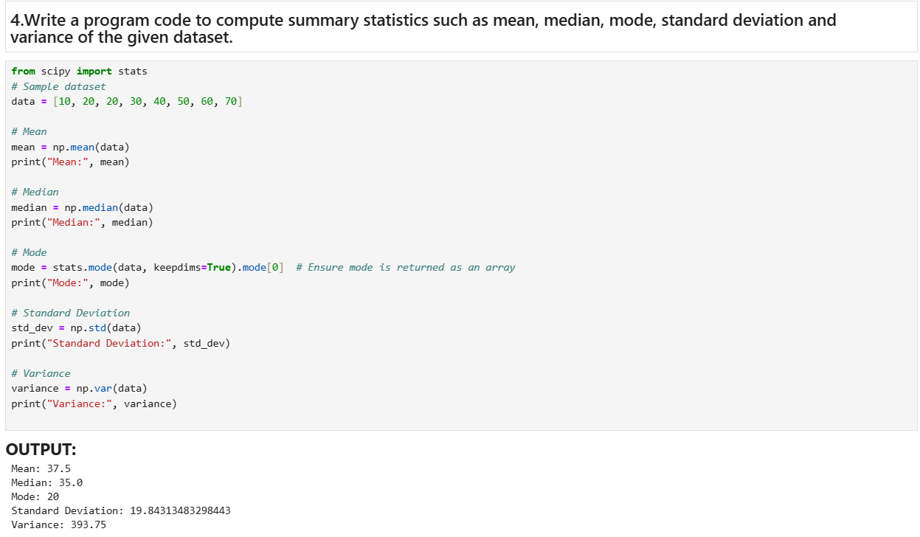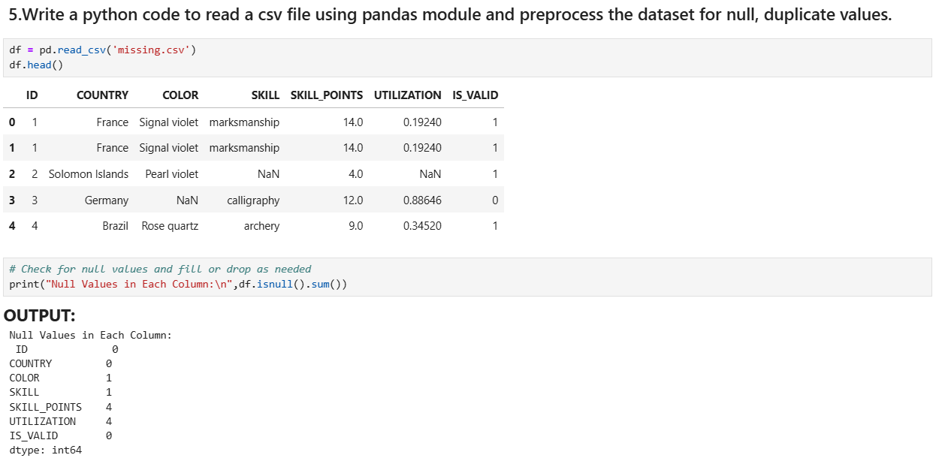

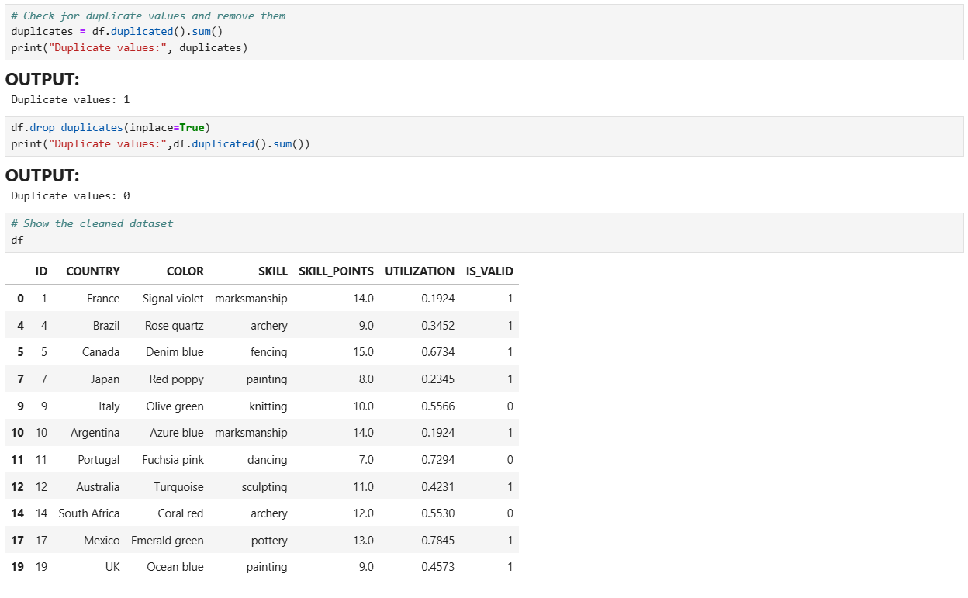

**PRACTICAL No.4 [BREATH FIRST SEARCH]**